

**Gilbert Police Department DDACTS**

**Data Driven Approaches to Crime and Traffic Safety**

**Program Overview**

DDACTS is an operational model that uses integration of location-based crime and collision data to establish effective and efficient methods for deploying law enforcement resources. Using geomapping to identify areas that have high incidences of crime and collisions, DDACTS uses traffic enforcement strategies that play a dual role in fighting crime and reducing collisions and traffic violations. Drawing on the deterrent of highly visible traffic enforcement and the knowledge that crime often involves the use of motor vehicles, the goal of DDACTS is to reduce the incidence of crime, collisions, and traffic violations across the country (DDACTS National Website). DDACTS analyzes and addresses long term crime and traffic collision trends, unlike Compstat, which is designed for short-term crime issues. Information and case studies on DDACTS are available online and have demonstrated the value of DDACTS, in crime and collision reductions. Select link: [Data-Driven Approaches to Crime and Traffic Safety (DDACTS) | National Highway Traffic Safety Administration (NHTSA)](http://www.nhtsa.gov/Driving+Safety/Enforcement+&+Justice+Services/Data-Driven+Approaches+to+Crime+and+Traffic+Safety+(DDACTS))

**Definitions**

DDACTS Zone: a specific geographic area for DDACTS program enforcement and community education and partnership, determined through data analysis of specific crimes and collisions for a three year historical period.

Directed Enforcement Area: an area determined for short-term enforcement, based on data analysis of recent spikes of crimes and/or collisions in specific geographic areas, and reported out during the Compstat portion of the ILP meetings. Directed enforcement is usually based on a single month of information.

ILP: intelligence led policing meetings. ILPs include Compstat reports, DDACTS reports, Intelligence & Analysis, Traffic directed patrol activities, Crime Suppression Team projects, and Drug Trends.

**Goals**

* **One Year:**
* Increase enforcement contacts by 20 percent in DDACTS Zone.
* Increase community reporting and involvement in DDACTS Zone.
* Reduce targeted crimes in DDACTS Zone by ten percent.
* Reduce collisions in DDACTS Zone by 5 percent.
* **Long Term; End Goal:**
* Maintain above listed goals for six consecutive months.

**Program Management**

DDACTS in Gilbert, AZ is operated utilizing the seven guiding principles of DDACTS, according to the DDACTS Operational Guidelines and the training workshops. This includes: *(1) partners and stakeholder participation, (2) data collections, (3) data analysis, (4) strategic operations, (5) information sharing and outreach, (6) monitoring, evaluations, and adjustments, and (7) outcomes*. DDACTS is managed within the Special Operations Division by the Special Operations Commander. The Special Operations Division includes the Criminal Investigations Section, Special Enforcement Section, and Tactical Operations Sections. The Special Operations Commander has overall operational management responsibilities. The Commander provides direction to the Special Enforcement Lieutenant, who has the primary role in planning and developing the DDACTS operational plan, and implementing the plan into action. The Special Enforcement Lieutenant has responsibility for plan design, with the commander’s consultation and information provided by the Intel and Analysis Unit and other stakeholders (Tactical Ops LT, CIS LT, Patrol, CST’s…). The Special Enforcement Lieutenant is responsible for communication to the affected public within the determined DDACTS zone, for community education and support, as well as responsibility for managing the tactical plan and enforcement. Community education will be done through HOA’s, Chamber of Commerce, media, and other public or professional groups to be affected. An information flow is required between the Special Enforcement Lieutenant, the Special Operations Commander, Crime and Analysis Unit, and enforcement units. The Commander or designee will provide monthly progress report cards at the ILP monthly meetings as well as six month final report cards on the program.

**Intelligence Gathering and Data Analysis**

One of the primary affected units within the division is the Intel and Analysis Unit. The crime analysts in this unit, as related to this program, are responsible for gathering five years of historical data on collisions and crime. The specific crimes being analyzed under this program are: vehicle burglary and theft, commercial and residential burglary, shoplifting and violent stranger crime. An analysis of crime and collisions will determine where the merged areas of crime and collisions are occurring, so DDACTS Zone can be determined for better efficiency and effectiveness in enforcement and community education, in an effort to achieve the goals of the Special Operations Division through the DDACTS program.

* The GPD crime analysts have extracted the data for the period of January 2010 to December 2014, providing a five year historical average, and mapped the clusters of crimes and collisions. Further, the unit has analyzed the data and created a merged, geo-based DDACTS zone for enforcement and education related to this program. The DDACTS zone will be an approximate 3 square mile area in South Gilbert, in the Santan North zone. This area comprises less than 5 percent of the total square miles of Gilbert and averages about 24 collisions, 5 vehicle crimes, 2 burglaries, 13 shopliftings and 3 violent crimes per month. The zone map and the statistics for the DDACTS zone is shown within the map and chart below:

**DDACTS 4 zone map****Gilbert Map showing DDACTS #3 and DDACTS #4 locations within the town**

**Focus Crimes, Collisions and Proactive Contacts Breakdown 2010 - 2014**

|  |  |  |  |  |  |  |
| --- | --- | --- | --- | --- | --- | --- |
| **FOCUS CRIMES** | **2010** | **2011** | **2012** | **2013** | **2014** | **5 YR MONTHLY AVG '10-'14** |
| VIOLENT | 21 | 26 | 28 | 27 | 30 | 2.59 |
| BURGLARY | 30 | 24 | 22 | 16 | 16 | 2.08 |
| VEHICLE CRIME | 63 | 58 | 49 | 60 | 40 | 4.58 |
| SHOPLIFTING | 225 | 138 | 113 | 146 | 142 | 12.73 |
| **TOTAL FOCUS CRIMES** | **339** | **246** | **212** | **249** | **228** | **22** |
|  |  |  |  |  |  |  |
| **COLLISIONS** |  |  |  |  |  |  |
| **TOTAL COLLISIONS** | **244** | **259** | **273** | **330** | **363** | **24** |
|  |  |  |  |  |  |  |
| **ONVIEW CONTACTS** |  |  |  |  |  |  |
| TRAFFIC STOPS | 4618 | 3765 | 3668 | 3940 | 4811 | 346.70 |
| SUBJECT STOPS | 916 | 787 | 892 | 931 | 645 | 69.52 |
| **TOTAL CONTACTS** | **5534** | **4552** | **4560** | **4871** | **5456** | **416** |

The crime analysts have responsibility for the initial, historical evaluation of the specific crimes and collisions, but also will conduct ongoing gathering and analysis of the data to provide information on the work being done within the DDACTS zone. Initially, specific crime and collision information will be provided to the tactical planners by the Crime Analysts, and tactical plans will be created to accomplish the program goals within the zone, specifically in regard to public communication and enforcement tactics. Once implemented, crime analysts will track the enforcement statistics within the DDACTS zone and provide the information to the division commander for analysis, reporting, and direction on tactical planning, strategic deployment and/or adjustment of resources and tactics. Reporting will occur at monthly intelligence Led Policing meetings in the form of monthly report cards and Final (six month) report cards. The final report cards will provide the necessary information to the Commander and Special Enforcement Lieutenant to direct continuance of operations within the zone, adjustments to the plan for the zone, or create a different plan based on the information provided. The process will continue its cycle in the current zone, an altered zone, or additional zones as required per the analysis and information provided.

**Enforcement**

The Special Enforcement Section and Patrol Officers working the Santan North Patrol Zone will be the primary personnel resources deployed into the program. Officers working DDACTS will be required to spend 20% of their on-duty enforcement time within the DDACTS zone in an effort to increase an overall percentage of work time in this designated area. CST, Day, and Night Traffic Teams will be shifted as needed by the Special Enforcement Lieutenant, based on ongoing analysis of activity, crime, and crashes. As the clusters of crime and crashes fluctuate, the teams’ hours will be adjusted accordingly for maximum effort and impact.

The Patrol Division will have a partially direct and partially indirect involvement in DDACTS 4. The DDACTS zone coincides with the Santan North Patrol Zone. Affected patrol officers work a larger patrol zone but will be required to focus at least 20 percent of their patrol work in the DDACTS 4 zone. They will have direct responsibility to DDACTS 4. Additionally, other patrol zone officers who are not required direct responsibility and who conduct enforcement and activity identified specifically within the DDACTS zone will be included within the analysis.

**DDACTS Timeline: Operational Period – July 1, 2015 – June 30, 2016**

|  |  |  |
| --- | --- | --- |
| Month | Meeting | DDACTS Phase |
| June 2015 | ILP  Command Staff | DDACTS Education (Department & Community)  Preview of DDACTS #4 |
| July 2015 | ILP | Implementation of DDACTS #3 |
| Aug, Sep, Oct, Nov & Dec 2015 | ILPs | Report Cards of DDACTS #4 and six month evaluation in January 2016 |
| Jan 2016 | Command Staff | Evaluation of DDACTS #4; Adjustments as needed |
| Feb, Mar, Apr, May & June 2016 | ILPs | Report Cards of DDACTS #4 |
| July 2016 | ILP | Final Report Card of DDACTS #4 |

**Reporting**

Although communications will be ongoing throughout the program, official program reporting will occur in the ILP monthly meetings. The DDACTS report card and final report cards will be briefed by the Special Operations Commander or designee, and will address the following:

* DDACTS zone (work area).
* Objectives
* Tactical Plan
* Outputs/Outcomes:
  + Results/performance to goals
  + Subject stops
  + Traffic stops
  + Dispatched Calls for Service
  + Officer Initiated Calls for Service
  + Pin map combining focus crimes and collisions in DDACTS zone, month to month and final report card timeline (6 month period).
* Overall successes and/or issues learned through the work period (monthly report card or final report card timeline).

**Gilbert Police Department DDACTS Program Communication and Work Flow**

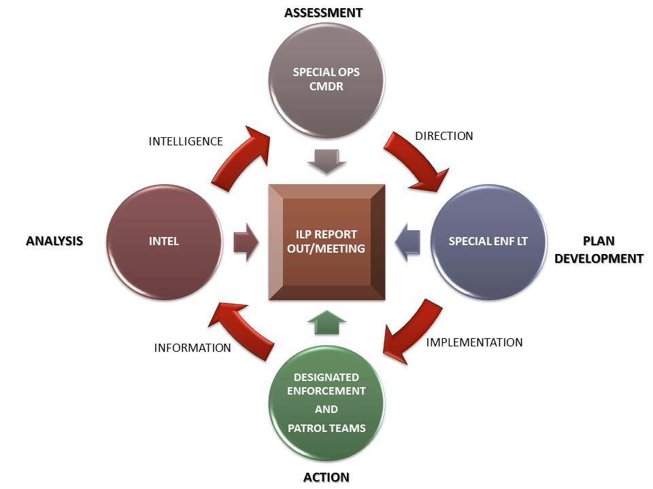

**Additional DDACTS Reference Material**

[**http://www.nhtsa.gov/ddacts**](http://www.nhtsa.gov/ddacts)

<http://www.nhtsa.gov/Driving+Safety/Enforcement+&+Justice+Services/Data-Driven+Approaches+to+Crime+and+Traffic+Safety+(DDACTS)>

<http://www.smartpolicinginitiative.com/sites/all/files/Webinars/DDACTS_OpGuidelinesMarch14.pdf>

<http://www.policechiefmagazine.org/magazine/index.cfm?fuseaction=display&article_id=1839&issue_id=72009/>

<http://www.nij.gov/topics/law-enforcement/operations/traffic/Pages/ddacts.aspx>

<https://www.iadlest.org/Projects/DDACTS.aspx>